STUDENT PEER MENTORING NETWORK
@CREATIVITY THINK (9483175986/7019689991)

ABSTRACT:
Student Peer Mentoring Network is a web-based platform designed to facilitate structured mentor-mentee interactions in colleges and coaching centers. The system provides automated mentor-mentee matching, session scheduling, progress tracking, feedback collection, and analytical dashboards. Students can register as mentors or mentees, set learning goals, book sessions, log completed interactions, and monitor progress. Administrators can verify mentor profiles, define matching rules, oversee active pairs, review feedback, and generate performance reports. Developed using Django and Django REST Framework for backend operations, and React with Redux and Chart.js for frontend interaction, the platform ensures efficient mentorship management, transparency, and data-driven insights..

INTRODUCTION OF THE PROJECT:
Educational institutions and coaching centers often lack a structured mechanism for peer mentoring. Manual coordination and informal tracking of mentoring sessions lead to inconsistent guidance, incomplete records, and low engagement. The Student Peer Mentoring Network addresses these issues by offering a digital system for automated matching, session logging, feedback collection, and progress monitoring. The platform enhances mentorship efficiency, fosters accountability, and provides actionable analytics for administrators to improve program outcomes..

PROJECT OBJECTIVES:

• Enable students to register as mentors or mentees
• Facilitate automated matching based on topics, availability, and criteria
• Allow booking and logging of mentoring sessions
• Track student progress, session history, and learning goals
• Collect feedback from mentees to ensure mentorship quality
• Provide administrators with verification, monitoring, and analytics dashboards
• Export reports for program evaluation and performance tracking
• Support structured and scalable mentorship programs

PROBLEM OF THE STATEMENT:
Institutions face challenges in managing peer mentoring programs due to lack of automated matching, incomplete session records, and insufficient feedback collection. Traditional methods often fail to track progress, measure satisfaction, or provide administrators with actionable insights. Student Peer Mentoring Network addresses these problems by providing a centralized platform that organizes mentorship activities, ensures proper monitoring, and enables data-driven decision-making to improve program effectiveness..

MOTIVATION OF THE PROJECT:
• To organize mentorship programs digitally for consistent tracking
• To automate mentor-mentee pairing based on relevant criteria
• To improve engagement and participation in mentoring activities
• To maintain accurate session logs and feedback records
• To provide administrators with actionable insights through dashboards
• To enable reporting and evaluation of mentoring programs
• To enhance academic support and skill development among students
• To foster a structured and professional mentoring ecosystem

BLOCK DAIGRAM OF PROJECT:

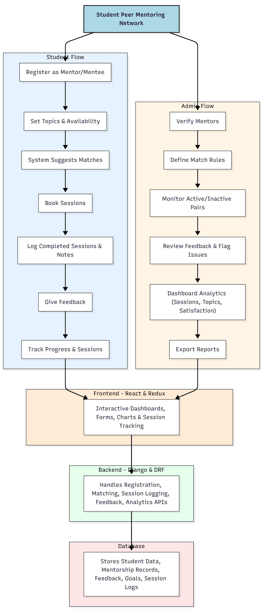

WORKING OF THE PROJECT:
Students begin by registering as mentors or mentees and specifying their expertise, learning interests, and availability. The system suggests suitable matches, which users can confirm to book mentoring sessions. After each session, students log completed interactions, notes, and provide feedback. Administrators verify mentors, define matching rules, and monitor active pairs. Dashboard analytics provide insights into session trends, topics covered, satisfaction ratings, and program engagement. Reports can be exported for evaluation. The backend manages user data, session logs, matching algorithms, and analytics calculations, while the frontend provides intuitive forms, dashboards, and visualizations for a seamless user experience..

SOFTWARE REQUIREMENT:
- Backend:
  - Python 3.x
  - Django
  - Django REST Framework
  - SQLite/PostgreSQL
- Frontend:
  - Node.js and npm
  - React.js
  - Axios
- Development Tools:
  - Visual Studio Code
  - Postman (for testing APIs)
  - Git/GitHub (for version control)
- Server/Deployment (Optional):
  - Gunicorn, Nginx, or Heroku/AWS for hosting

ADVANTAGES OF THE PROJECT:

• Structured mentor-mentee matching system
• Real-time session tracking and logging
• Feedback collection ensures mentorship quality
• Dashboard analytics for administrators
• Facilitates academic and personal growth for students
• Improves engagement and participation in mentoring programs
• Provides exportable reports for evaluation
• Scalable for multiple departments or coaching centers

APPLICATIONS OF THE PROJECT:
• College mentorship programs
• Coaching centers and educational institutions
• Peer-to-peer learning networks
• Skill development initiatives
• Student guidance and support systems

REFERENCES:

- Django REST Framework Documentation — Django Software Foundation. Django Documentation. Available: https://docs.djangoproject.com/
- Django REST Framework. DRF Documentation. Available: https://www.django-rest-framework.org/
- React. React Official Documentation. Available: https://reactjs.org/docs/getting-started.html
- Redux. Redux Documentation. Available: https://redux.js.org/introduction/getting-started
- PostgreSQL Global Development Group. PostgreSQL Documentation. Available: https://www.postgresql.org/docs/
- MySQL. MySQL Reference Manual. Available: https://dev.mysql.com/doc/
- Git. Git Documentation. Available: https://git-scm.com/doc
- Node.js. Node.js Documentation. Available: https://nodejs.org/en/docs/
- Axios. Axios Documentation. Available: https://axios-http.com/docs/intro
- Socket.io Documentation – https://socket.io/docs/

